Assyrian Bishop Mar Awa Royel Replies to the Unity offer by Chaldean Catholic Patriarch
by Orthodoxy Cognate PAGE on July 10, 2015
in Featured News, News
inShare0
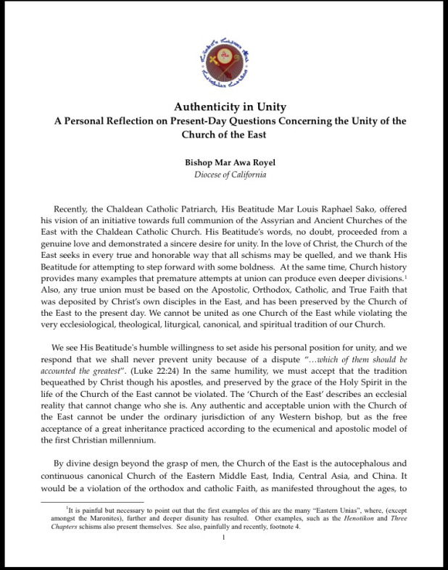
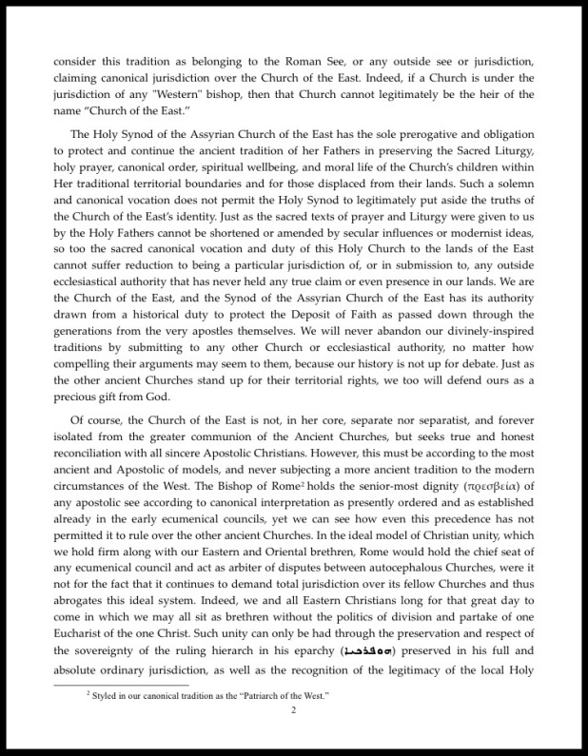
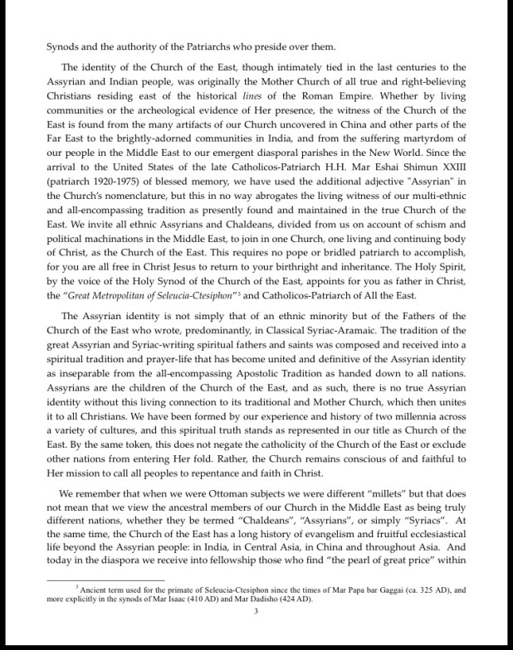
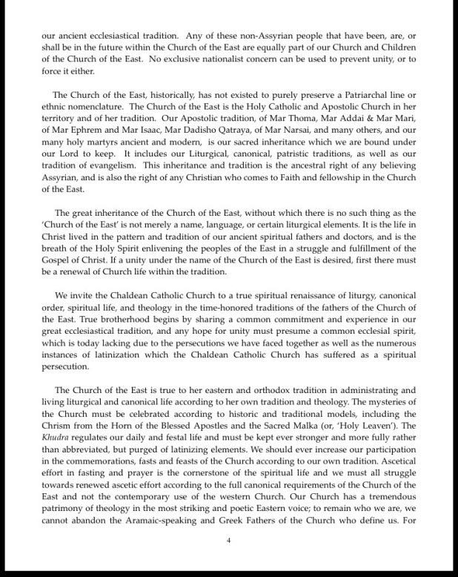
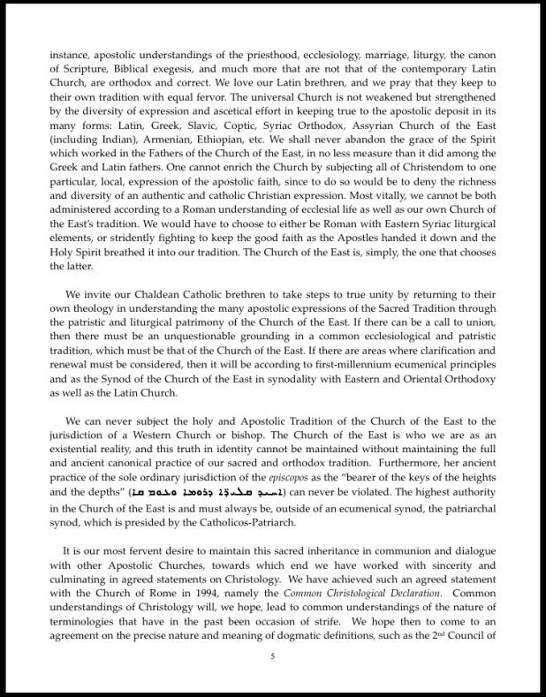
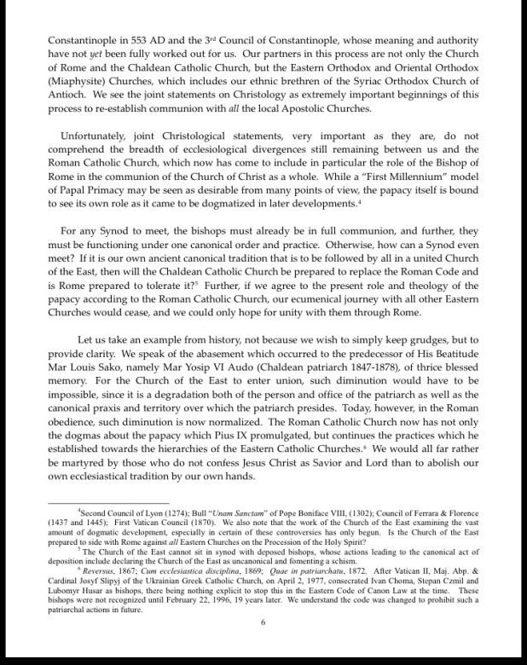
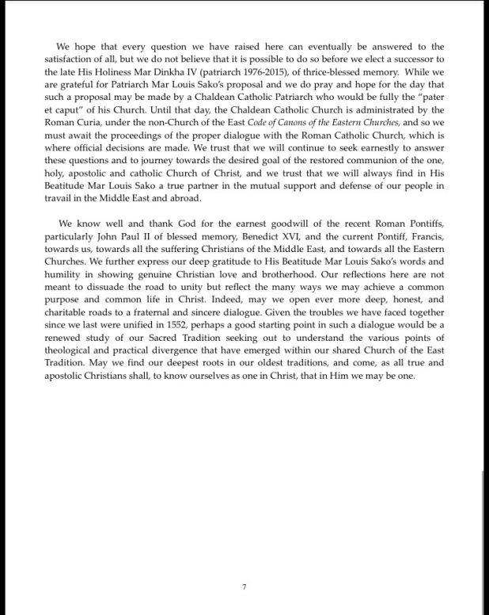
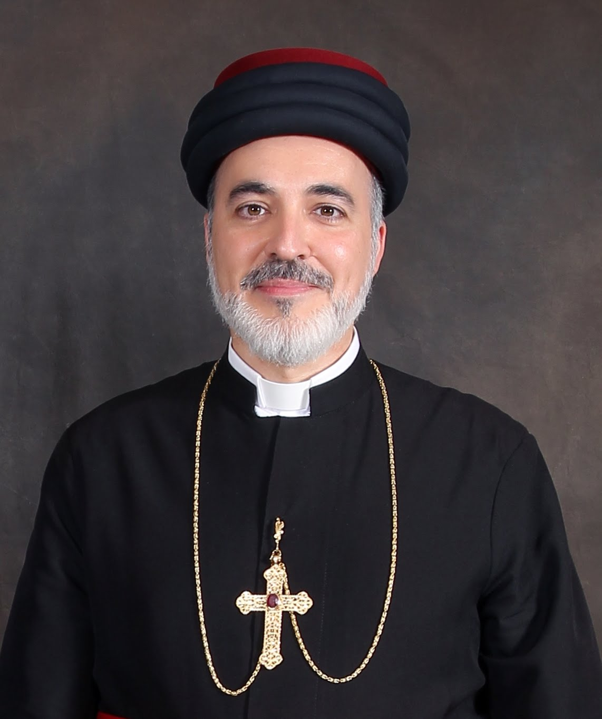
Mar Awa Royel of California
One Holy Catholic Apostolic Assyrian Church of the East – July 2015
Authenticity in Unity: A Personal Reflection on Present-Day Questions Concerning the Unity of the Church of the East.
===============

